Lower Back Exercises – Level 1

1. Lying Down Single Knee to Chest

Lie on your back with both legs bent and feet flat on the floor. Relax and allow your lower back to feel the floor. Place hands behind or top on of your right knee and gently pull it towards your chest. You may choose to keep your left leg bent or extend it, allowing it to rest on the floor for a deeper stretch. Be sure to keep your lower back pressed to the floor. Hold the stretch for 15-30 seconds, being sure to breathe regularly. Slowly release the stretch, bringing the right knee down and right foot back to the floor. Repeat this stretch with the other leg. Perform this stretch 2-3 times on each leg and twice daily. This action stretches the hip, buttocks muscles and back muscles.

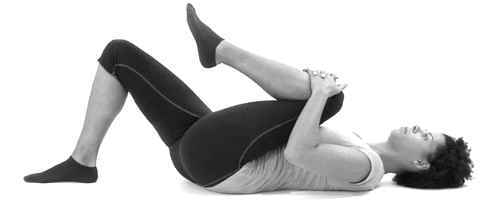

1. Lying Down Both Knees to Chest

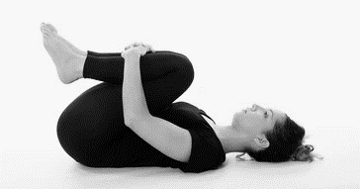Lie on your back with both legs bent and feet flat on the floor. Relax and allow your back to feel the floor. Place hands behind or top on of your knees and gently pull them towards your chest. Hold the stretch for 15-30 seconds, being sure to breathe regularly. Slowly release the stretch and allow the feet to return to the floor. Repeat this 2-3 times. This action stretches the lower back, buttocks muscles and abdominal muscles.

(Pelvic tilt maneuver on the reverse side)

1. Pelvic Tilt Maneuver

In ALL movement of the human body, control of the pelvic complex and core stabilizers is imperative! Pelvic tilt maneuvers reinforce awareness and control of important muscles in the lower back, core, and torso that, when done regularly, can reduce pain and poor chronic movement patterns.

1. Lying Down

Imagine there is a rod going through your hips horizontally that you can rotate with your hands. When you rotate the imaginary bar forward, the curve in your low back will become larger and the space between your spine and the floor will increase. When you rotate the imaginary bar backwards, the curve in your low back will decrease and the flat of your back will touch the floor. This is the movement you are attempting - to remove the curve in your low back and bring your lumbar spine to the floor by contracting abdominal and core muscles only. Hold this for 6 seconds and repeat 6-10 times. Do this twice daily or more!

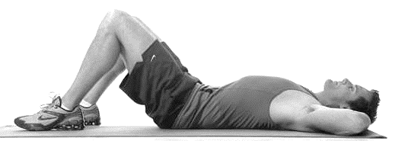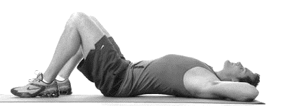

1. Standing Up

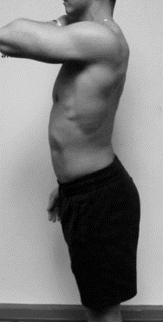Pelvic tilts can also be performed while standing. Repeat the same process but keep knees slightly bent and ‘soft’. Take a breath in and on the breath out, engage your abdominal muscles, tuck your tailbone underneath you, while maintaining upright upper body posture. Hold for 6 seconds and repeat 6-10 times twice a day or more! Remember that this maneuver is about control of specific musculature, and the range of motion achieved is actually quite small.

**Melissa O'Loughlin, DC, CACCP • Maggie Benham, DC**

**Stephanie Meglino, DC • John Petro, DC • Jessica Berlin, DC**

142 Bemis Street Canandaigua, NY 14424

chosenspotchiropractic.com

585.394.2030