FOOT CARE

Your doctor can speak specifically with you about a care plan that reflects your individual needs, but these basic guidelines will be helpful to the average foot.

Shoes

Our feet spend a large portion of their time inside our shoes - we should keep their health in mind when choosing the shoes to buy and wear. Here are some things to look for in shoes that will be kind to your feet:

- Wide toe base
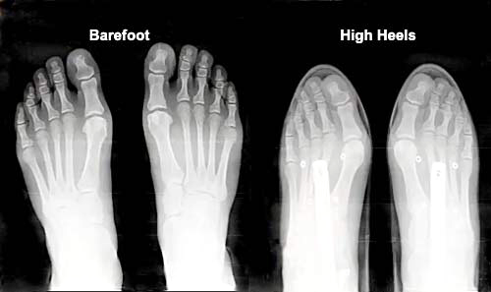
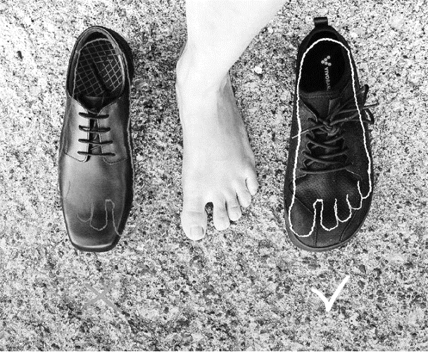
This allows your toes to spread out, grip the ground, and cushion your foot through every stride.
- Zero Drop
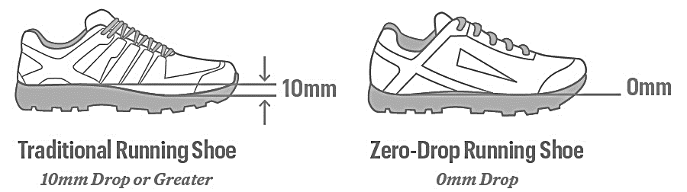
This means no heel or pitch to the shoe base. The shoe will have the same thickness of sole under the forefoot and heel. This encourages a low-impact stride and allows you to feel connected to the ground.
- Flexible Sole
A sole should have enough flexibility to allow proper range of motion of the many small joints in the foot. Rigid soles limit the foot’s ability to function as designed.

** If you do factory work or hard labor that requires a substantial steel toe, these will be harder to find. A wide toe base with minimal drop will likely be your best option. And be sure to wear those only for the necessary work times. **
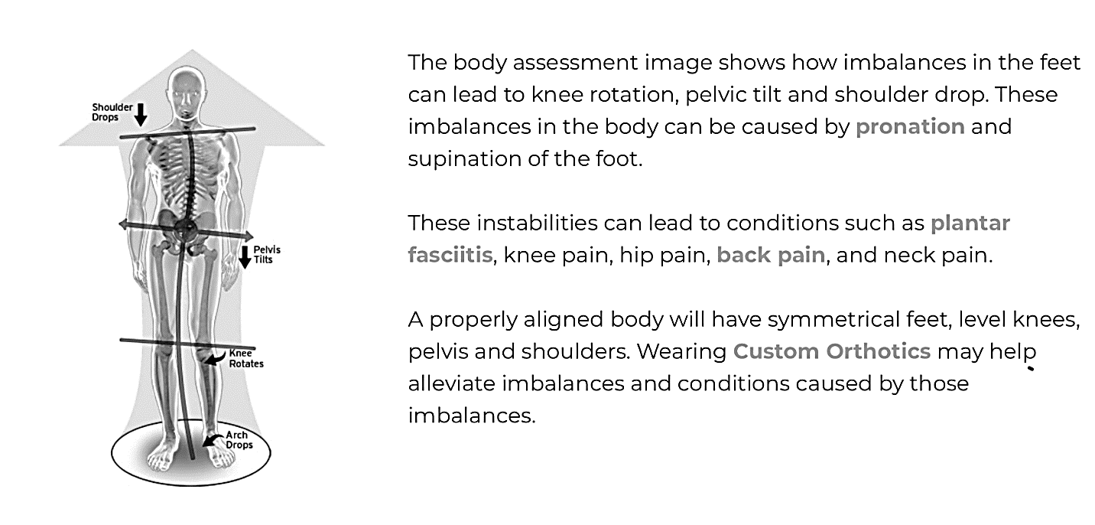
Foot Leveler Custom Orthotics
For the right patient, these custom stabilizers are flexible and totally unique to your foot. They are custom made, not “custom fit.” We have a 3D foot scanner in our office to evaluate your feet, any collapsing in your arches, and resulting postural distortions. If you and your doctor decide that you would benefit from our custom-made orthotics, one week later they will be in your shoes creating balance every step you take.

The body assessment image to the right shows how imbalances in the feet can lead to other distortions and instabilities, which in turn lead to conditions such as plantar fasciitis, knee pain, hip pain, back pain, and neck pain.

A properly aligned body will have symmetrical feet and level knees, hips, and shoulders. Wearing custom orthotics may help alleviate imbalances in the feet and correct the resulting conditions.

Foot Pain, Inflammation, Injury Care at Home
- Epsom Salt Soaks
Soak your feet in hot water (to your tolerance and safety) adding a ½ cup of Epsom salt to water that covers the feet. Relax and let soak for 20-60 minutes.
- Castor Oil
Before bed, generously rub castor oil over the entire foot and give self-massage where needed to tired and sore feet. Place socks over the feet.
General Foot Care to Increase Strength and Stability
- Foot Drills
Exercising the feet is often overlooked; however, they are such an integral part of our everyday life and there are plenty of muscles, joints, and ligaments that would greatly benefit from intentional exercise. For more information, see our “Foot Drills” handout.
- Rolling
Gently roll your feet over a tennis ball or lacrosse ball. The goal is not to stretch the plantar fascia but to smooth adhesions and improve range of motion in the foot joints. Use caution with your pressure.
- Grounding and Barefoot Work
Mounting evidence continues to show benefits of connecting the human body to the earth’s surface. The physiological rewards are known as “grounding” and many people report feeling more balanced, more connected, and less anxious in doing so. We recommend getting barefoot and breathing regularly, bringing awareness down to your feet and away from your thoughts which take so much of our daily attention.
While walking/running on an untrained bare foot could have potentially negative effects, we recommend getting barefoot for grounding, foot drills, or other functional foot stability exercises regularly to strengthen the intrinsic muscles of the feet. This will support mechanical integrity from the ground up.
Melissa O'Loughlin, DC, CACCP • Maggie Benham, DC
Stephanie Meglino, DC • John Petro, DC • Jessica Berlin, DC
142 Bemis Street Canandaigua, NY 14424
chosenspotchiropractic.com
585.394.2030

