**WHAT IS THE DEAD BUG**

The Dead Bug is a great exercise for lower back pain. The exercise avoids spinal flexion and keeps the lower back in a safe and neutral position while building a solid core at the same time. The dead bug can also be used to build spinal stability and core strength even if you do not have any current back pain. This exercise can help rehab lower back pain, prevent future injuries, and build a strong and stable core that aids in other types of exercise or activities of daily living. Read on to learn how to properly perform the Dead Bug.

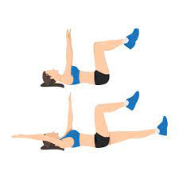**HOW TO DO A DEAD BUG**:

1 Begin by lying on the floor facing

up in a supine position (on your back), with knees bent and in line with your hip joints, arms reaching up over your chest.

2 Your back should remain in neutral position on the floor.

3 Be sure that the back of your skull remains in contact with the floor for the duration of the exercise, this will prevent any strain on the neck.

4 Lower your left leg as you simultaneously lower your right arm behind your head.

5 Take a deep breath in as your belly rises and your lungs fill.

6 Brace your core as if someone is about to step onto your stomach. Hold here for a count of 5-10 seconds. You can build up this time as your core and lower back strengthen.

7 Return the right leg and left arm to the starting position.

8 Repeat on the other side.

9 Perform at least 5 sets.