Bicipital Tendon Adjustment Aftercare

The biceps brachii muscle has a long head and a short head, as depicted in the image below. The tendon for the long head of the biceps originates on the scapula (shoulder blade), passes over the head of the humerus, and descends into the intertubercular groove of the humerus. This tendon can slip from the groove (medially) with sometimes little to no trauma, but often with specific motions or mechanisms.

The doctor made an adjustment to your bicipital tendon today. It may be necessary to repeat this adjustment on subsequent visits, especially depending on your day-to-day activities and occupation; however, you can maximize the duration that today’s adjustment will hold by following these aftercare instructions:

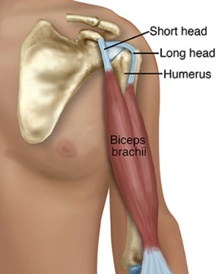

1. Keep your arm down by your side as best as you can for the rest of the day. If the doctor advises, you may need to avoid lifting your arm for tomorrow as well.
2. No sleeping on the shoulder for the next 3 days.
3. Ice the shoulder 3 times per day for the next 3 days. Apply ice for 10-15 minutes.
4. Apply T-relief cream to the shoulder 2 times per day for approximately 1 week. T-cream is available at the front desk if you don’t already have some or something comparable at home.

If you have any questions, feel free to contact the office at (585) 394-2030.

**Melissa O'Loughlin, DC, CACCP • Maggie Benham, DC**

**Stephanie Meglino, DC • John Petro, DC • Jessica Berlin, DC**

142 Bemis Street Canandaigua, NY 14424

chosenspotchiropractic.com

585.394.2030