Neck Stretches

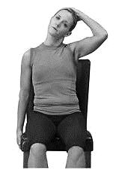

1. Seated Upper Trapezius Stretch

Place your right hand over the top of your head and gently pull your head down towards your right shoulder. Hold for 30 seconds and then relax. Repeat 4 times. Switch to your left arm and gently pull to your left shoulder. Hold for 30 seconds and then relax. Repeat 4 times.

1. Seated Levator Scapulae Stretch

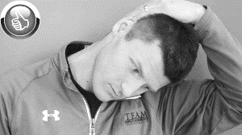Reach over the top of your head and place your right hand on the left back side of your head (with your pinky finger near the top of your ear.) Now gently pull your head down and to the right. Lightly resist the pull of your hand with your neck muscles. Hold this resistance for six seconds and then relax your neck muscles as you try to pull your head a little further down and to the right. Perform this stretch 3 times. Repeat 3 times on the opposite side.

1. Chin Tuck

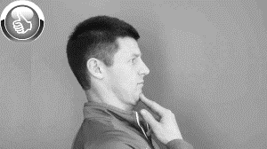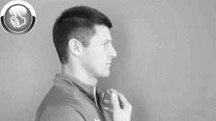To position yourself for this stretch, start by sitting upright. Then create a stable jaw position by pressing your tongue against the roof of your mouth, bringing your lips together, and keeping your teeth apart slightly. Once you’ve obtained that neutral jaw position, pull your jaw straight back into a “double-chin position.” Hold this for a few seconds and release. Be sure to just release your chin without jutting your chin further forward. Repeat this 8-10 times.

**Melissa O'Loughlin, DC, CACCP • Maggie Benham, DC**

**Stephanie Meglino, DC • John Petro, DC • Jessica Berlin, DC**

142 Bemis Street Canandaigua, NY 14424

chosenspotchiropractic.com

585.394.2030