DEEP CORE and PELVIC FLOOR

The ***deep*** core involves the diaphragm, pelvic floor, transverse abdominus and multifidus muscles. These muscles work together to provide support for your *entire body*. If one is overactive or underactive, engaged incorrectly, or engaged at the wrong time, dysfunction can result. If you have pain trying to maintain correct posture throughout the course of the day, you may have dysfunction in these deep core muscles. Fortunately, we can specifically train the muscles of the deep core to return proper function. Follow along with these exercises that will coach you through the proper form of engaging the *deep* core. As you begin to improve engagement of the deep core throughout these exercises, you will be able to increase deep core engagement throughout your daily movements.

1. Diaphragmatic Breathing
2. It is important that we first discuss breathing with the diaphragm. The diaphragm, as depicted above, is the roof of the deep core musculature. We should be engaging our diaphragm when we breathe throughout the day, but it is especially important to engage it when we are specifically trying to work our deep core *as a whole*. Sit in a comfortable position or lie flat on the floor, your bed, or another comfortable flat surface and relax your shoulders. Put a hand on your chest and a hand on your stomach. Breathe in through your nose for about 2-3 seconds. You should experience the air moving through your nostrils into your abdomen, making your stomach expand. During this type of breathing, make sure your stomach is moving outward while your chest remains relatively still. Purse your lips (as if you’re about to drink through a straw), press gently on your stomach, and exhale for about 2-3 seconds. Repeat several times for best results.

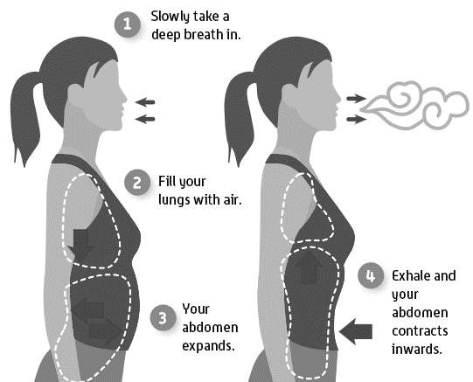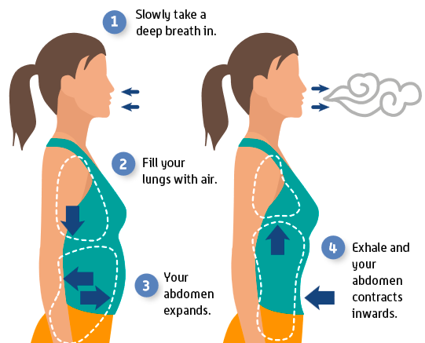

cccccccccccccccccccccccccccccccccc

ccccccccccccccccccccccccc

cccccccccccccccccccccccccccccccccccccccc

ccccccccc

1. Kegel Contraction

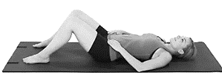A Kegel contraction is an integral piece to engaging the pelvic floor and can be done in an isolated manner or during other deep core exercises. To perform an isolated Kegel, lay flat on your back with knees bent. Place your fingers towards the bony part of the front of the hips. You will perform the Kegel contraction while you exhale. The contraction occurs by squeezing the muscles of the pelvic floor as if you were stopping the flow of urine. You should feel the lower abdominal region become tight under your fingers. Fully relax after holding the position for five seconds. This can be tricky - the key is to pull the pelvic muscles *up* rather than bearing down to feel a contraction in this region. Additionally, patients must pull their bellies in, rather than out, when engaging the transverse abdominis muscle during the exhale.

1. Cat-Cow

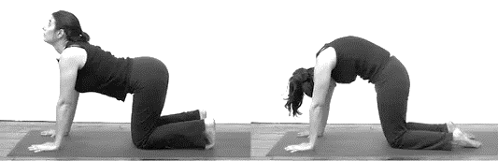Kneel on the floor in an all-fours position on your hands and knees. Line your hands up under your shoulders and knees under your hips. Start with a straight neutral spine and avoid collapsing between the shoulders. To perform the “cat” portion of the exercise, exhale, tuck your chin and drop your head while pressing your back upwards, and engaging your pelvic floor (perform a **Kegel contraction** here) and abdominals while you arch your back like a cat. To perform the “cow” portion of the exercise, inhale, lift the head and draw the chest upwards, allowing your belly to sag and spine to arch downwards. Remember to keep the hips above the knees – do not sit back into your hips. Repeat this for a total of 10 cat-cow cycles.

1. Bird Dog

Kneel on the floor in an all-fours position on your hands and knees. Line your hands up under your shoulders and knees under your hips. Start with a straight neutral spine and avoid collapsing between the shoulders. Drag the toes of the one foot along the ground as you extend your leg straight behind you, pushing your heel out (dorsiflexing the foot – don’t point your toes), and lift until the right leg is parallel to the floor (can perform a **Kegel contraction** here). Simultaneously, lift the opposite arm straight out in front of you while maintaining your back and neck position and keeping your support arm straight, with the hand lined up under the shoulder. Hold for about 10 seconds, return to the starting position, and relax your musculature before performing with the opposite limbs.

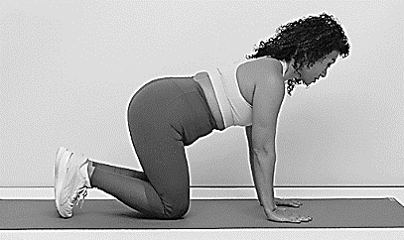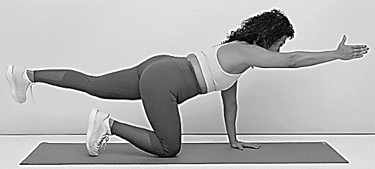

1. Dead Bug

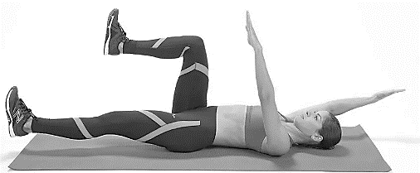Lie flat on your back and flex your hips and knees to 90 degrees with arms straight out in front of you. Similar to the Bird Dog, hands should be over your shoulders and knees over your hips. Contract the deep core as you extend one leg and the opposite arm as shown below (**Kegel!**), hold for about 10 seconds, and return to the starting position. Relax your musculature before repeating with the opposite limbs.

**Melissa O'Loughlin, DC, CACCP • Maggie Benham, DC**

**Stephanie Meglino, DC • John Petro, DC • Jessica Berlin, DC**

142 Bemis Street Canandaigua, NY 14424

chosenspotchiropractic.com

585.394.2030